Different Types Document

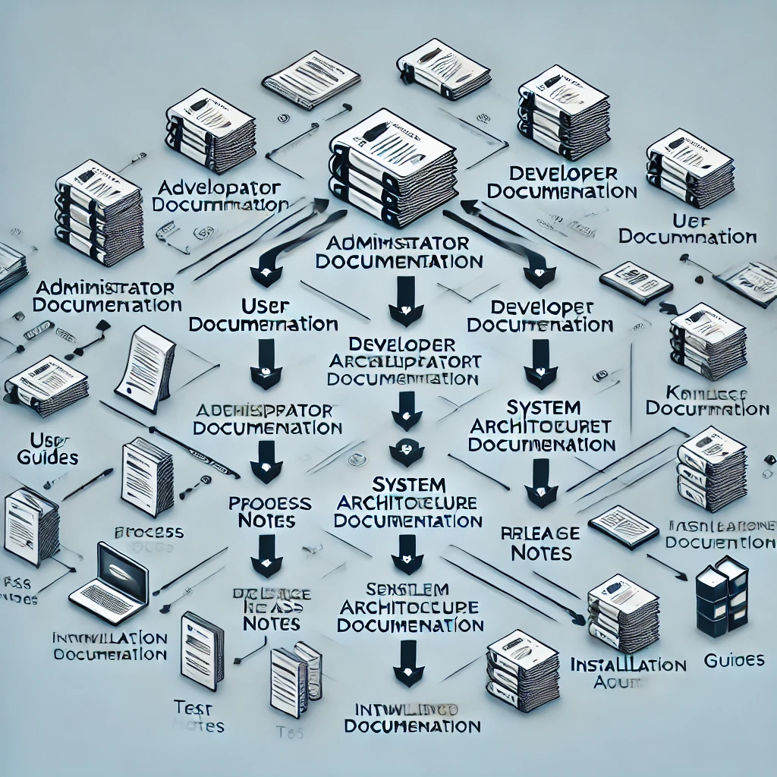

There are various types of **technical documentation**, each serving specific purposes and audiences. Here’s a breakdown of the most common types:

**1. User Documentation**

* **Purpose**: Designed for end-users to help them understand how to use a product, software, or system.
* **Audience**: General users with little technical expertise.
* **Examples**:
  + **User Guides**: Detailed manuals or instructions on how to use a product’s features.
  + **Getting Started Guides**: Introductory instructions to help users quickly begin using the product.
  + **FAQs**: Frequently asked questions with answers to common issues or queries.
  + **How-to Articles**: Step-by-step guides to complete specific tasks.

**2. Administrator Documentation**

* **Purpose**: Guides for system administrators on configuring, managing, and troubleshooting complex systems or applications.
* **Audience**: IT administrators, system operators, or technical staff.
* **Examples**:
  + **Admin Guides**: Instructions on managing, configuring, and securing systems.
  + **Configuration Manuals**: Details about setting up systems, networks, or databases.
  + **Troubleshooting Guides**: Common problems, diagnostic steps, and resolution procedures.
  + **Maintenance Manuals**: Information about system health, maintenance schedules, and upgrades.

**3. Developer Documentation**

* **Purpose**: Provides detailed technical information to developers for building or extending applications.
* **Audience**: Software engineers, developers, or programmers.
* **Examples**:
  + **API Documentation**: Descriptions of APIs, including endpoints, request/response structures, and usage examples.
  + **SDK Documentation**: Guides for using Software Development Kits (SDKs), including code samples and installation instructions.
  + **Code Documentation**: In-line code comments or separate documents explaining how a codebase works.
  + **Developer Guides**: Tutorials or instructions to integrate, extend, or customize applications.

**4. Product Specifications (Specs)**

* **Purpose**: Detailed descriptions of a product’s features, performance, and design specifications.
* **Audience**: Engineers, developers, or technical teams.
* **Examples**:
  + **Technical Specifications**: Lists of hardware or software characteristics (e.g., speed, memory, power consumption).
  + **Design Documents**: Architectural diagrams and descriptions of how the system or product is built.
  + **Requirements Documentation**: Descriptions of functional and non-functional requirements of a system or software.

**5. System Architecture Documentation**

* **Purpose**: Explains the overall structure and components of a software or hardware system.
* **Audience**: Developers, architects, and engineers.
* **Examples**:
  + **Architecture Diagrams**: Visual representations of system components and their interactions.
  + **Component Descriptions**: Detailed descriptions of each module, service, or subsystem.
  + **Interaction Diagrams**: How different parts of the system communicate, such as data flow or process flows.

**6. Process Documentation**

* **Purpose**: Describes workflows, business processes, or internal procedures to ensure consistency and efficiency.
* **Audience**: Business analysts, project managers, internal teams.
* **Examples**:
  + **Standard Operating Procedures (SOPs)**: Step-by-step instructions on routine processes within an organization.
  + **Workflows**: Visual or textual descriptions of business processes or workflows.
  + **Policy Documents**: Guidelines for compliance, governance, or internal practices.

**7. Release Notes**

* **Purpose**: Inform users, developers, and administrators about the updates, changes, bug fixes, and new features in a product release.
* **Audience**: End-users, developers, administrators.
* **Examples**:
  + **Version Histories**: Lists of product versions with detailed information on what changed, was fixed, or was added.
  + **Upgrade Instructions**: Instructions on how to upgrade systems or applications to the latest version.

**8. Test Documentation**

* **Purpose**: Records the testing procedures, test cases, and test results to ensure product quality.
* **Audience**: QA testers, developers, and project managers.
* **Examples**:
  + **Test Plans**: Overall strategy and approach for testing the product.
  + **Test Cases**: Specific conditions and steps to verify product functionality.
  + **Test Reports**: Summary of testing results, including success rates, defects found, and testing coverage.
  + **Bug Reports**: Documentation of issues, bugs, or defects found during testing.

**9. Knowledge Base (KB) Articles**

* **Purpose**: Provide quick, self-service support for users looking for solutions to common issues or learning more about a product.
* **Audience**: End-users, support teams, or technical staff.
* **Examples**:
  + **Troubleshooting Guides**: Quick tips for resolving known issues.
  + **Step-by-step Procedures**: Articles on completing common tasks or configurations.
  + **FAQs and How-Tos**: Informative pieces answering common questions or explaining features.

**10. Training Manuals and eLearning Materials**

* **Purpose**: Offer educational content to train users, employees, or developers on how to use a product or system effectively.
* **Audience**: End-users, employees, or developers.
* **Examples**:
  + **Training Manuals**: Printed or digital guides with lessons and exercises.
  + **Video Tutorials**: Step-by-step visual instructions for learning how to use tools.
  + **eLearning Courses**: Interactive training modules or courses that cover essential product usage or skills.

**11. Installation and Setup Documentation**

* **Purpose**: Guides for installing and setting up hardware or software.
* **Audience**: IT staff, engineers, or technical users.
* **Examples**:
  + **Installation Guides**: Detailed steps to install hardware or software.
  + **Setup Guides**: Instructions to configure a system post-installation.
  + **Hardware Installation Manuals**: Diagrams and steps for physical installation of devices or machines.

**12. Help Documentation (In-Product Help)**

* **Purpose**: Provides real-time assistance and information within the product or software itself, often in the form of tooltips, tutorials, or help centers.
* **Audience**: End-users and technical users.
* **Examples**:
  + **Contextual Help**: Tooltips or links to help topics embedded within the user interface.
  + **Interactive Walkthroughs**: Onboarding tutorials that guide users through the product.

**13. White Papers**

* **Purpose**: In-depth reports or guides that provide authoritative insight or explanations on technical topics or solutions.
* **Audience**: Decision-makers, stakeholders, technical experts.
* **Examples**:
  + **Industry Standards**: White papers that explore standards, methodologies, or trends in a specific industry.
  + **Technical Overviews**: In-depth explanations of a product’s technology or architecture.

Each type of technical documentation serves specific needs and can vary in depth and complexity depending on the target audience and the purpose of the product, system, or process.